IEP Handbook
2020-2021 School Year

Welcome to Louisiana Schools for the Deaf and Visually Impaired (LSVI).

This handbook is designed to assist you with your Individual Education Plan (IEP) responsibilities. It is very important that you read the IEP Handbook and comply with the information that it contains. If, during the school year, you have any questions or problems, feel free to contact the IEP Facilitator. State department policies and procedures change frequently.

Table of Contents

Getting Started page 3
IEP Folder Sections pages 4-7
IEP Procedures pages 8-13
Updating and Maintaining Records page 15
IEP Process pages 16-50
Closing Out IEPs and IEP Progress Reports page 51
IEP Progress Report Procedure page 52-55
JCAMPUS pages 56-57
IEP Facilitator’s Contact Information page 58

Special Education Reporting System

SPECIAL EDUCATION REPORTING (SER): IEP Forms User Guide
https://serp.doe.louisiana.gov/Ser/IEPForms4/HelpWin/IEP_User_Guide.pdf

The Special Education Reporting (SER) System provides for the establishment of a statewide special education student database from which specified reports from the student record can be generated. The specified reports generated enable special education personnel to: follow the provision of services to individuals; monitor the timeliness and appropriateness of these services when judged against the sections of the Louisiana Revised Statutes at R.S. 17:1941, et seq; Bulletin 1706, Regulations for Implementation of the Children with Exceptionalities Act; and the Individuals with Disabilities Education Act (IDEA, Part B and Part C).

Special education personnel have the ability to collect, report, and process information on individual students through automated means. Data are captured on an individual from the point of referral to pupil appraisal personnel and from the provision of services until the time of exit from special education.

The SER system can be accessed at the following web address: https://serp.doe.louisiana.gov/ser

*Remember to turn off Pop-Up Blockers*

To access SER, each teacher will be provided with a User ID and Password. The “User ID” will begin with LDOE\e304___. Each number is specific to each teacher.

The password MUST be reset every 90 days.

To reset your password, use the following link: https://password.doe.louisiana.gov

Resetting a Password Using the Password Reset System (PRS): To change an initial password or to reset a forgotten or expired password, LDE has implemented a self-service password reset system called PRS. The PRS URL is https://password.doe.louisiana.gov/.
The PRS User Guide can be found at https://password.doe.louisiana.gov/PRSHelp.pdf.
When resetting your password, LDO\ is not used, enter the e304___ only.

Section I: Getting Started

CHECKING AND MAINTAINING IEP FOLDERS

Each case manager has a list of students for which IEPs they are responsible for coordinating, collaborating, and managing.

The IEP folders are located in the IEP Facilitators’ offices.

Make sure that all required items are in the IEP folder throughout the school year. Verify the students’ classes are scheduled appropriately according to their IEP and that each student is receiving all services on the IEP (Speech, APE, OT, PT, Special Education Instruction, Counseling, etc.).

It is every teacher’s responsibility to be informed as to what each IEP states for each student they teach. This information can be accessed from SER.

SER provides the most current IEP goals, objectives, accommodations, testing program, etc. for each student. If SER is not available, the information can be found in the student’s current IEP which is located in the IEP Facilitator’s office.

Health care plans and emergency care plans also need to be known by the teacher.

IEP FOLDER SECTIONS

Section 1: IEP
- Due Process Checklist (Attached to IEP)
This is a form that documents all attempts to contact the parent/guardian regarding an IEP conference or a Manifestation Determination Review conference.
- Prior Notice of Proposed or Refused Action (Attached to IEP)
This form should be used: 1) if a parent does not attend the IEP meeting, 2) if significant changes have been made to the IEP, 3) if the parent recommends changes and the IEP team disagrees, or 4) if the IEP team recommends changes and the parent disagrees, 5) to document that the parent is in agreement with the IEP as written.
- Parental Notification Letter (Attached to IEP)
This is a letter notifying the parent/guardian and other meeting attendees of the date, time, place, and purpose of the IEP meeting.
- Age of Majority Transfer Student and Parent Letter (Attached to IEP, if applicable)
There are two letters, one for the parent and one for the student. These letters must be sent home if the student is turning 16 within the IEP year or older at the time of the IEP meeting. The letters inform the parent and the student that the student retains the right to make educational decisions once he/she reaches the age of 18.
- Parent Permission for Agency Invite letter (Attached to IEP, if applicable)
This form is sent home before conducting an IEP meeting for a student who is turning 16 years old within the IEP year and older. It should be sent home before the Parental Notification letter is sent home. The parent signs this form giving permission for the school to invite an agency to the IEP meeting. You cannot invite an agency to the IEP meeting unless the parent signs this form giving permission for you to do so. A copy of this form must be attached to the IEP. This must be completed before every IEP meeting.
- IEP Collaboration Form for the current IEP meeting (Attached to IEP, if applicable)
This form documents the collaboration between IEP team members when drafting the current IEP. (April Dunn Act students)
- Current IEP Document
The original, signed IEP with all required documents attached should be kept in the IEP folder. The IEP must be less than one year old. If the IEP is more than one year old, a new IEP must be convened immediately.
- Site Determination Form (Attached to IEP)
This form is used to document the reason a student is enrolled at LSD instead of their home parish. This page is added during the “draft IEP process” and attached to the IEP. It is signed by the ODR.
- April Dunn Act Eligibility form (Attached to IEP, if applicable)
- Goal Summary form (Attached to IEP, if applicable)

- Alternate Assessment/LEAP Connect Eligibility Form (Attached to IEP, if the student meets the criteria)
This is a form used to determine if a student qualifies for Alternate Assessment.
- Health Care Plan (Attached to IEP)
All students that have medical concerns or are on medication at school must have a current health plan in the IEP folder. This information is obtained from the Student Health Center. Case managers should inform all the student’s teachers if there is an Emergency Care Plan in place.
- Individual Graduation Plan (Attached to IEP, if applicable)
This is a list of the courses the student plans to take in high school. A copy of the Individual Graduation Plan (IGP) must be attached to every IEP that addresses Transition. This plan can be obtained from the school’s guidance counselor. It must be uploaded in SER and attached to the current IEP.
- Individual Graduation Plan for LAA1 Students/Education Career Plan for LAA1 Students (Attached to IEP, if applicable)
This is a plan of study for students who are eligible to participate in LAA1 testing. These students follow the Louisiana Connectors, according to the Louisiana Department of Education.
- Summary of Performance Criteria Form (Attached to IEP, if applicable)
This is a form that must be completed for graduating seniors.
- Parental Consent form for Medicaid Billing (Attached to IEP)
This form gives LSDVI permission to bill Medicaid for certain services they provide for the student. This form should be attached to the IEP.
- Behavior Intervention Plan (BIP) (Attached to IEP, if applicable)
The BIP is a contract that targets inappropriate behavior(s) and rewards appropriate behavior(s). The BIP must be attached to the IEP.
- Communication Plan (Attached to IEP, if applicable)
All students who are deaf or hard of hearing or have limited communication skills are required to have a current Communication Plan attached to the current IEP.
- Assistive Technology Consideration Checklist (Attached to IEP)
Assistive technology services provide the necessary support for students to access the curriculum through the use of appropriate equipment, software, and services. IDEA mandates that all students with an identified disability be considered for assistive technology.
- AIM Form- (Attached to IEP)
- Verification form- (Attached to IEP)
- Receipt of receiving IEP signature page

Section 2: Evaluation
Current Evaluation
A copy of the current evaluation is kept in the IEP folder. The evaluation must be less than three years old. If the current evaluation is missing, you must request one from the Admissions and Records Office. The dissemination date is the date of the evaluation.

Section 3: School Academic Information
- Current IEP Progress Reports
Every nine weeks period a progress report must be completed for each student you case manage. The original progress report must be sent home and a copy must be kept in the student’s IEP folder. The progress report indicates what progress the student has made towards achieving his/her IEP objectives addressed during the specific grading period. If the objective has been addressed, indicate if the student has achieved the objective or indicate his/her progress toward achieving the objective. All Progress Reports that coincide with the current IEP are kept in the IEP folder. The progress report form can be accessed from SER software. (**This procedure will be explained in further detail in Section VII of this handbook.**)
- Interim Grade Report and Report Cards
A copy of the interim grade report and report card for each reporting period are kept in the student’s IEP folder for the entire school year. Interim grades, along with comments, related to the student’s academic courses are reported via JCAMPUS at the 4 ½ week mark of each 9 weeks period. Report cards, along with comments, related to the student’s academic courses are reported via JCAMPUS at the end of every 9 weeks period.
- Progress Monitoring Forms (PM2)
A Progress Monitoring Form (PM1) for each student you teach is to be completed at the 4 ½ weeks mark. If you see academic or behavior problems, a PM2 meeting will be held with academic counselor, teacher, parent and student. The PM2 form will be filed in the student’s IEP folder.
- IEP Collaboration Forms (APRIL DUNN ACT students use this for teachers to collaborate.)
APRIL DUNN ACT students require that all teachers teaching the student that have APRIL DUNN ACT applied to a course must collaborate and sign form indicating that you have discussed best practices to serve the student.
- School Level Building Committee (SBLC) form-
SBLC forms are used when documenting excessive absences, lack of progress, retention of student
- Discipline Referral forms-
Discipline referral forms can be found in JCampus

Section 4: Assessment
- A copy of the student’s current statewide assessment results can be found in JCAMPUS or provided by the school test coordinator or the district test coordinator.

Section 5: Extended School Year Services (ESYS)
- Current ESYS IEP
If the student has an Extended School Year Services IEP, the original ESYS IEP is kept in the IEP folder. This should include the Due Process Form, Parental Notification Letter, and the ESYS IEP.
- Current ESYS Eligible/Ineligible Letter
This letter informs the parent if a student is eligible or ineligible to receive ESYS services. This letter is sent home after the eligibility/ineligibility decision is made. A copy of the letter should be kept in the IEP folder.
- Current ESYS Documentation Forms
The Criteria Documentation Form and the documentation form(s) that coincides with the criteria(s) used to screen the student should be kept in the IEP folder. These are forms that indicate what criterion was used to screen the student for ESYS. Any attachments that go with the ESYS form(s) should be attached to this form.

Section 6: Transition
Transition Assessments
Any student who is turning 16 years old within the IEP year and older requires two transition assessments per IEP year. The Teacher of Record will complete the assessments and interest inventories for those students requiring a transition plan. A copy of the data is kept in the Section One with IEP supporting documents of the IEP folder. Documentation of student participation in transition activities are in this section: career fairs, college fairs, job fairs.

Section 7: Parent Contact Log
Current Parent Contact Log
Each teacher and/or case manager will keep a log of all contact and attempts made to the parent and/or student (if 18 years or older) on a form. Types of acceptable contact include, but are not limited to the following: phone calls, meetings, notes sent home, progress reports sent home, emails, face-to-face meetings, etc. Parent communication must be entered into the system using JCAMPUS.

Section II: IEP Procedures

The Individualized Education Program (IEP) is a LEGAL document which describes the educational plan and services that will be provided to the student. All teachers who teach a student are responsible for implementing the student’s IEP.

IEP meetings must be reconvened on a yearly basis and each time a reevaluation results in a change of exceptionality. An IEP must never be allowed to expire.

LSDVI requires that the Parental Notification Letters be sent at least 30 days before the scheduled “Review” IEP meeting date. “Initial” IEP meeting should be held within 30 days from the evaluation disseminated date. These deadlines must be adhered to.

BEFORE THE IEP MEETING
Before the IEP meeting, the local education agency (LEA) which is Louisiana School for the Visually Impaired (LSVI), may “draft” an IEP. At the IEP meeting, the IEP team must review each section of the IEP and assure agreement. A draft IEP can never be regarded as a final document. Any section of the IEP can be modified by the IEP team members at the time of the meeting.

1. REVIEWING DOCUMENTATION
Before creating an IEP, you need to review the following information:
- Current IEP
- Current Evaluation/Reevaluation (must be within the last 3 years)
- Scores from any classroom based assessments administered (for the current school year)
- Current assessment scores
- Most recent Interim Grade Report or Report Card
- Most recent IEP progress Reports
- Behavior Intervention Plan (BIP), if applicable
- For Students turning 16 years old within the IEP year and older – obtain results of any informal/formal interest testing (interviews, questionnaires, interest inventories, etc.), Career Planning Portfolio, results of vocational assessments, “Target Areas for Transition Planning" worksheet, Individual Graduation Plan, LAA 1 Career Plan, etc…
- Current Individual Health Plan (IHP)
- Current Vision and Hearing Screening Results

2. GETTING READY FOR THE MEETING
It is required by law to review the student's IEP annually. Begin preparing documentation for the IEP conference at least 60 days before the student's current IEP expires.

Follow the steps below to begin the IEP process:
- Start a draft copy of the IEP using the Louisiana Department of Education SER system.
- Set up a collaboration meeting using the IEP Collaboration Form with all of the student’s teachers. (APRIL DUNN ACT)

Complete “Close-Out” procedures for previous IEP goal/objectives and IEP progress reports. (Further explanation included in Section V of this handbook)

3. DRAFT IEP TO IEP FACILITATOR
Make sure the draft copy of the IEP is submitted to the IEP Facilitator at least 30 days before the student’s IEP meeting date. The IEP Facilitator will review the draft IEP. If there are any suggestions for revision, the IEP Facilitator will inform the case manager.

4. NOTIFYING IEP COMMITTEE OF THE MEETING
- A Parental Notification Letter is sent to the parent/guardian and any other team members invited to the IEP meeting 30 days before the meeting. The IEP Facilitator is responsible for completing the letter and e-mailing to the appropriate IEP team members.
- The following should be sent to the parent/guardian before the IEP meeting (usually with the Parental Notification Letter):
  - Louisiana’s Educational Rights of Children with Disabilities booklet
  - Draft of SER IEP Forms
- The case managers are responsible for completing the draft IEP in SER according to the above timelines. The IEP Facilitator will mail all documents to the student’s mailing address no later than 30 days prior to the IEP meeting date.

It is the Teacher of Record’s responsibility to contact the parent/guardian and student at least one week prior to and the week of the scheduled IEP meeting to determine attendance. This data should be documented on the parent contact log.

DURING THE IEP MEETING
1. PREPARING TO CONDUCT THE IEP MEETING
The following documentation/items should be brought to the IEP meeting:
- Blue pen
- Draft IEP including all attachments applicable to the student
- “Closed-out” IEP—any/all goals and objectives that were achieved are to be recorded in SER and hand-written on the old IEP.
- “Closed-out” IEP Progress Reports
- Other: work samples, tests, data, observation results, transition assessments, etc…

The student should be at the meeting unless the parent/guardian waives his/her attendance (this should be documented on the IEP Participants section). Students should be encouraged to attend IEP meeting if old enough.

Attendees required for an IEP meeting are:
- Officially Designated Representative, known as ODR (usually Principal or Assistant Principal)
- Evaluation Coordinator (if applicable)
- Special Education Teacher
- Parent/Guardian
- Student
- Adult Agency (if applicable)
- Related Services personnel (if applicable)
- IEP Facilitator (if applicable)

- The ODR should provide the following to the parent at the time of the meeting:
- Verbal Explanation of the Louisiana’s Educational Rights of Children with Disabilities
- Draft of SER IEP Forms which includes all parts of the IEP

2. IEP MEETING PROCEDURE
The ODR must be present during the meeting proceedings. The IEP Committee should discuss all aspects of the IEP during the meeting. Suggested changes and accommodations should be made to the parts of the IEP that were drafted using blue ink if a computer is not available. The IEP Committee should make sure the parent participates in and understands all aspects of the student's IEP.

- Provide the parent/guardian with a Verbal Explanation of the Louisiana’s Educational Rights of Children with Disabilities.
- Introduce IEP meeting participants.
- Have IEP participants sign the IEP Participants section of the IEP.
- Provide parent/guardian with draft of IEP.
- For students turning 16 years old within the IEP year and older (younger, if deemed necessary), discuss the Transition Services Page.
- Discuss the General Student Information Page of the IEP.
- Discuss the Goals and Objectives pages on the Instructional Plan pages of the IEP.
- Discuss the Accommodations page.
- Discuss the Program/Services page.
- Discuss the Placement/Least Restrictive Environment page.
- Discuss the Site Determination form.
- Discuss April Dunn Act form. (if applicable)
- Discuss Alternate Assessment options/forms. (if applicable)
- Discuss Health Care Plan completed by the Student Health Center and entered by the case manager.
- Discuss Individual Graduation Plan. (if applicable)
- Discuss Medicaid Billing Consent form.
- Discuss Behavior Plan. (if applicable)
- Complete the Communication Plan for Students who are Deaf or Hard of Hearing or limited verbal communication.
- Discuss Assistive Technology form.

3. SIGNATURES
ALL SIGNATURES SHOULD BE IN BLUE INK! ALL SIGNATURES SHOULD BE DATED WITH THE SAME DATE AS THE IEP MEETING DATE!
- All attendees at the IEP conference will sign the IEP as “IEP Participants”.
- The Officially Designated Representative (ODR) will sign the IEP in several places.
  - IEP Participants section
  - Placement page (at the very bottom).
  - Any/all supporting documentation pages.

**Note: Do not make the IEP official in SER. Only IEP Facilitator will make IEPs official.

AFTER THE IEP MEETING: The case manager will inform the student’s teachers of the “new” IEP which is to be implemented accordingly.
LSDVI’s Timelines for SER IEPs

LSDVI policy is that all IEPs must be opened in SER as a “draft” at least 60 days prior to the IEP due date:
- The IEP Facilitator will utilize the IEP calendar provided by the IEP Facilitator to determine 60 days prior to the meeting date.
- The IEP Facilitator opens a “draft” IEP in SER.

LSDVI policy is that all draft IEPs must be completed at least 30 days prior to the IEP meeting date.
- Case managers will e-mail the IEP Facilitator when the student’s draft IEP is ready for review.
- The IEP Facilitator will review the draft IEP and email the case manager with any recommendations.

LSDVI policy is that all draft IEPs are due at least 30 days prior to the scheduled IEP meeting date:
- The IEP Facilitator will send a Calendar Invite/email to the appropriate team members at least 30 days prior to the IEP meeting date.
- Case managers will e-mail the IEP Facilitator when completed draft is ready to print.
- The IEP Facilitator will print the draft and include with the Parental Notification Letter packet which will be mailed home.

AMENDING AN IEP

It is an IEP team’s decision as to whether an amendment is needed to the student’s IEP. Amending an IEP does NOT alter the annual review date of the IEP. The annual review date remains the date listed on the current IEP. For example, the student’s annual IEP was held on December 1, 2020; an amendment was completed December 21, 2020; the student’s IEP will still expire December 1, 2021.

Only the IEP Facilitator should enter amendments in SER based on the decision of the IEP team. Notify your IEP Facilitator when an amendment is needed. The parent/guardian must receive a parent notification letter of an IEP amendment date, place, and time BEFORE an amendment can be made to the IEP.

Please notify your IEP Facilitator via email of any amendments needed. Please put: “Amendment Request” as the subject. In the email, list the amendment needed and the reason the amendment is being requested.

An Amendment IEP is held to discuss only those portions of the IEP that are to be amended.

Section III: Updating and Maintaining Records

IEP PROGRESS REPORTS AND COLLABORATION FORMS
Every nine weeks period an IEP progress report must be completed for each student you case manage. The original progress report must be sent home and a copy must be kept in the student’s IEP folder. The progress report indicates what progress the student has made towards achieving his/her IEP objectives addressed during the specific grading period.

Indicate if the student has achieved the objective or indicate his/her progress toward achieving the objective. Also include the date and level of achievement. Be sure to document on both the IEP (put date and save) and the student’s progress report if the student has achieved a goal and/or objectives.

INTERIM GRADE REPORTS AND REPORT CARDS
Interim grade reports (4 ½ week report) and Report Cards (9 week report) are to be filed into the student’s IEP folder in Section 3. If a student has a ‘D’ or an ‘F’, documentation using the PM2 form MUST be filed in the IEP folder in Section 3.

SBLC
All School Level Building Committee meeting documents are kept in Section 3.

Discipline Referrals
All discipline referral reports from JCampus are to be kept in Section 3.

ASSESSMENT RESULTS
IEP Facilitators are responsible for filing any assessments completed throughout the school year in the student’s IEP folder.

PARENT CONTACT LOGS
Teachers are responsible for entering parent contact in JCAMPUS. Some examples on when to contact parent(s);
- Confirmation of attendance to IEP meetings
- Positive comments regarding the student’s progress
- If a student is receiving failing grades
- If a student is receiving discipline referrals which are negatively affecting academic progress
- Up-coming IEP meetings

Section IV: IEP Process
GENERAL INFORMATION

Louisiana’s Education Bulletins, BESE
- http://bese.louisiana.gov/documents-resources/policies-bulletins
- Bulletin 1530: IEP Handbook
- Bulletin 1706: Regulations for Implementation of the Children with Exceptionalities Act
- Bulletin 1508: Pupil Appraisal Handbook

FAPE (Free Appropriate Public Education)
- Taken from Bulletin 1706:
- “A free appropriate public education shall be available to all students residing in the state…” (page 1, Bulletin 1706)

IEP (Individualized Education Program)
- Taken from Bulletin 1706:
- “…the term individualized education program or IEP, a written statement for each student with a disability that is developed, reviewed, and revised in a meeting…” (page 32, Bulletin 1706)
- The IEP is a LEGAL document.
- It is to be INDIVIDUALIZED.

Confidentiality of Information
- IEPs are confidential.
- Meetings (informal and formal) are to be held in private with only those who are involved in the student’s case.
- Never speak about another student during meeting (informal or formal). This is a violation of confidentiality.
- FERPA—Family Educational Records and Privacy Act of 1974.

Bulletin 1530-Louisiana’s IEP Handbook for Students with Disabilities
- An IEP must be held at least annually.
- A Re-Evaluation must be held at least once every three years.
- Three types of IEPs:
  - Initial
  - Review
  - Interim

Bulletin 1508-Pupil Appraisal Handbook
- Chapter 7. Disabilities
- Definitions and Criteria of Eligibility of Exceptionalities

Explanation of Rights
- Parents must be given a copy of the Rights Booklet each time an IEP and/or Re-Evaluation is to be held.
- The parent is asked at the beginning of each meeting if they have received the Rights Booklet and do they have any questions. If necessary, a verbal explanation of their rights will be given at the start of each meeting.

In accordance with the IDEA, IEPs must contain the following:
- A statement on the student’s present levels of academic achievement and functional performance, including how the student’s disability affects the student’s involvement and progress in the general education curriculum.
- A statement of measurable annual goals, including academic and functional goals, designed to meet the student’s needs and enable the student to be involved in and make progress in the general education curriculum.
- A statement of the special education and related services and supplementary aids and services that will be provided to enable the student to advance appropriately toward attaining annual goals and making progress in the general education curriculum.

How to Access SER

Type in Website URL:
https://serp.doe.louisiana.gov/SER

**Make sure to turn off Pop-up Blocker**

Enter User ID
- Each teacher will have a unique User ID.
- It will begin with LDOE\e304___.
Enter Password
- Each teacher will maintain their own passwords.
- Your SER password MUST be changed every 3 months.
- If you have trouble logging in, then proceed to the Password Reset System Page. Reset you password and attempt to log in again.

SER Home Page
- The SER Home page is the first page the user will see after logging into the system.
- This page provides important information regarding usage of the system. If there is any important information regarding the status of the system, such as scheduled down time of the system, it will be highlighted on this page.
- Please be sure to make note of any and all information on this page.
- Click the Continue button to advance to the Student Search page.

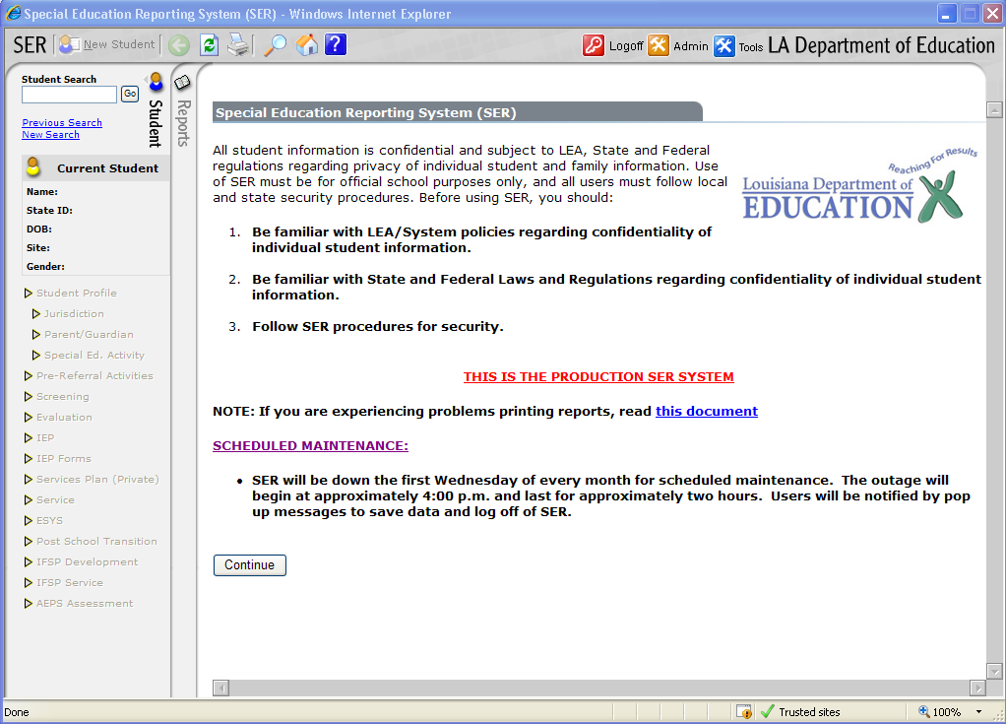

***REMINDER***
Students’ names and participants’ names ARE NOT ALLOWED in the text boxes of the IEP.
Instead of the student’s name, you can put “The student…”
Instead of the participants’ names, you can put “the parent, the therapist, the teacher, the case manager, etc…”
Student Search
The student Search page allows the user to quickly retrieve a student matching the specified search criteria.

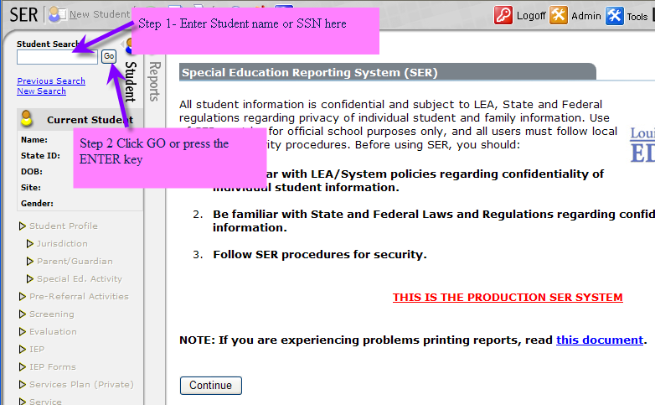

OR
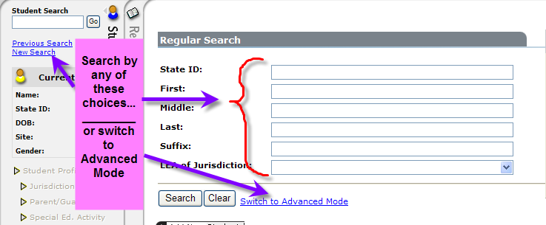

How to Access a Student’s Records in SER
- Once you have typed in a student’s name, a list of possible students will appear on the bottom half of the screen.
- To select the student you want, click on the student’s state ID number. It will be highlighted in Blue.

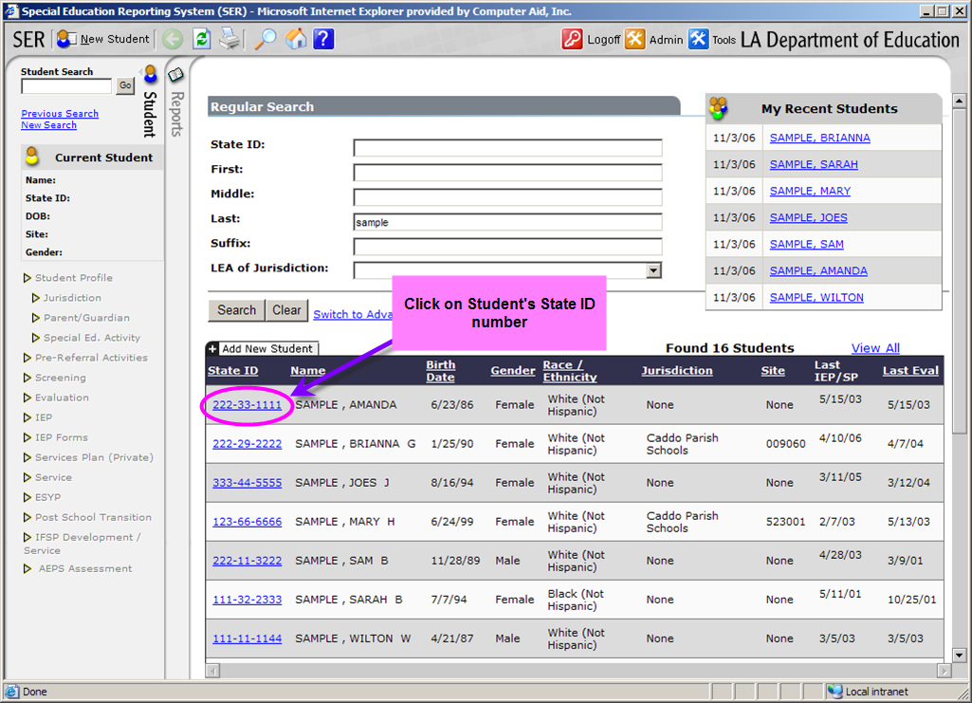

Student Tab
The Student tab provides a quick way to search for students, track which student is currently being worked on, and easily move between different information areas of a student‘s record.

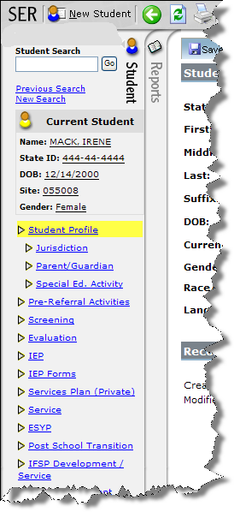
Current Student
- SER allows access to only one student’s record at a time.
- The Current Student area contains basic information, such as Name, State ID, Date of Birth, and Gender of the student currently accessed.
- When a student record is selected from the Student Search page, this area will be updated to show record information for that single student.
- If no student has been selected or if currently adding a new student, this area will remain blank. It will also be blank when the user returns to the Student Search page.
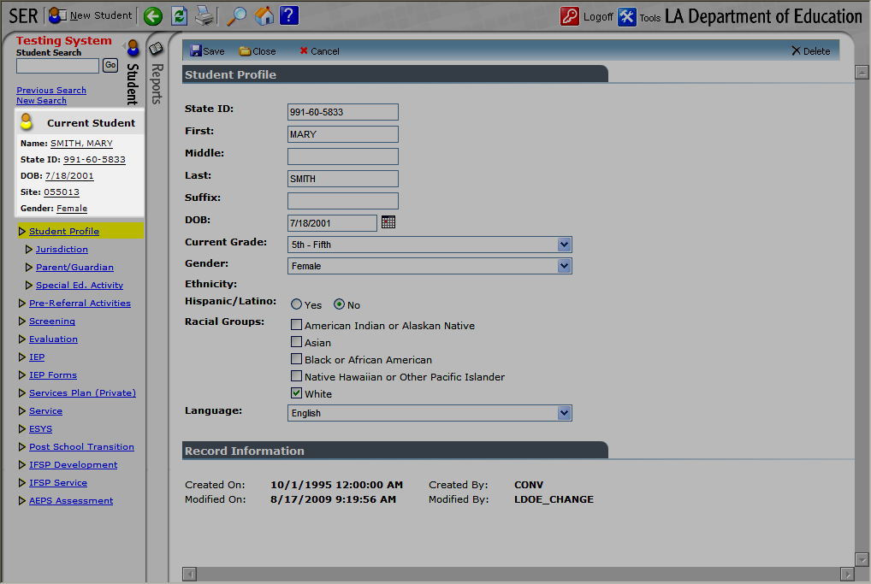

Student Profile
- Access to the student’s Jurisdiction, Parent/Guardian, and Special Education Activity can be found using the links below.
- You will have access to the entire IEP (which has been scanned) using the “View Attachments” feature.

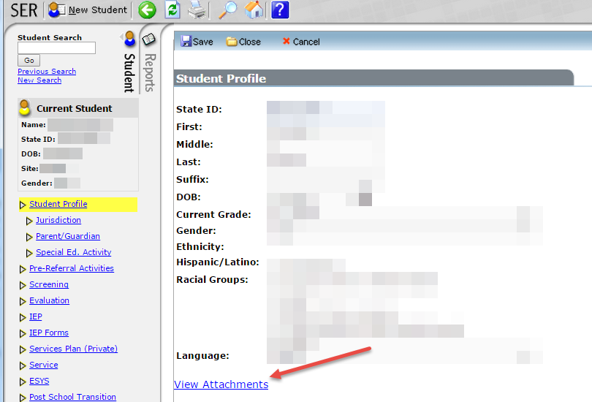

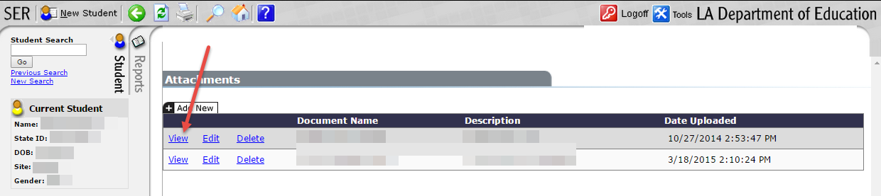

View Attachments: The attachment feature is found on the first page of SER when viewing a student’s record. It is located on the Student Profile page. To add an attachment or see what attachments are already in the file, click View Attachments.
IEP Forms Link
- To access the student’s IEP, click on the “IEP Forms” link.
- Click “View” or “Print” to access a student’s IEP, if it has been made Official.
- If the IEP is still in Draft mode, it will read “Edit” or “Print”.

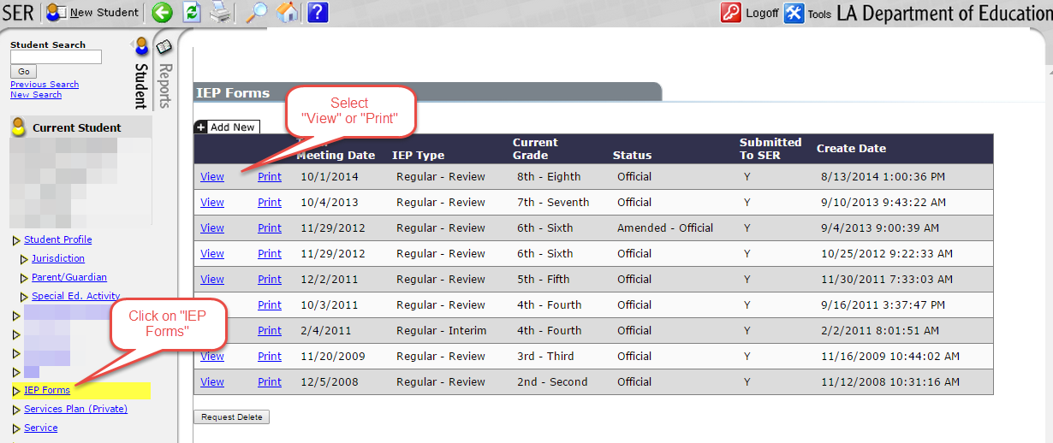

Creating an IEP
- Click “IEP forms “
- The IEP Forms Page will display
  - Displays summary IEP information (i.e., Meeting Date, IEP Type, Current Grade, and Create Date)
  - Contains IEP Print Option, Status, and the Submitted to SER flag
  - Option to View an existing IEP
  - Option to Edit a Draft IEP
  - Option to Add New to create a Draft IEP

IEP Forms Operations
The top toolbar allows the users to perform the following operations:
- Refresh the screen
- Save the data on the current page . IMPORTANT: Save your work at least every 15 minutes when working in SER.

IEP Form Help
Each IEP form is equipped with a help screen.
Throughout the form you can click on the help button
- Additional help related to the current IEP form can be obtained by scrolling the window to the particular field help section.
- The HELP window is closed by clicking the X in the upper right hand corner of the popup.
The question mark at the top of each form can be clicked to display the SER/IEP Forms User’s Guide in PDF format.

Spell Check
All text areas on the IEP may be checked for proper spelling.
Spell check is a manual process and is invoked by clicking the spell check icon on the top toolbar.

Spell check must be completed on EACH individual SER page.

Description of SER Pages:
- SER #1: Transition Services
- SER #2: General Student Information
- SER #3: Instructional Plan
- SER #4: Accommodations
- SER #5: Program and Services
- SER #6: Services and Placement
- SER #7: Site Determination
- SER #8: Extended School Year Services (ESY)
- SER #9: Progress Report
- SER #10: April Dunn Act
- SER # 11: Goal Summary
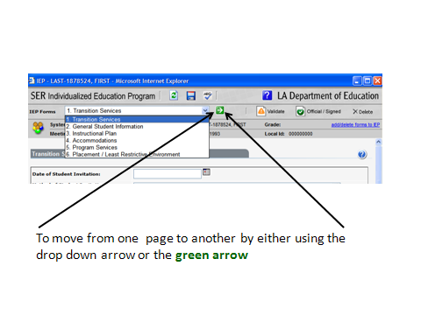
SER #1: Transition Services
- Transition Services Page will be completed by the IEP Facilitator.
- Transition services must be completed for all students turning 16 years old within the IEP year and older.
- If your student does not require Transition Services proceed to the GSI page. Do not enter anything on Transition Services page.

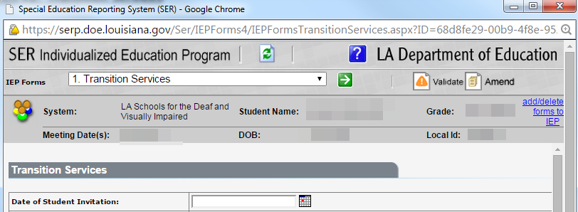
SER #2: General Student Information (GSI)
Type of IEP
- For the majority of the IEPs, the case manager will select “Regular-Review”.
Team Meeting Date
- Using the prior notice and/or the IEP calendar, enter the student’s IEP meeting date.
Current Grade
- Using JCAMPUS, enter the student’s current enrolled grade.
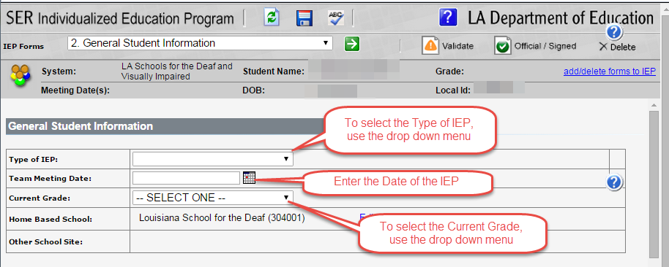
List of IEP Participants
- The case manager will use page 3 of the Prior Notice Letter to obtain the names and positions of all participants invited to the IEP meeting
Age of Majority (if applicable)
- Age of Majority is marked for a student who is turning 16 years old within the IEP year and older.
Education Rights of Children with Disabilities
- The Rights Booklet is mailed home with every prior notice letter. This box is checked for all IEPs.
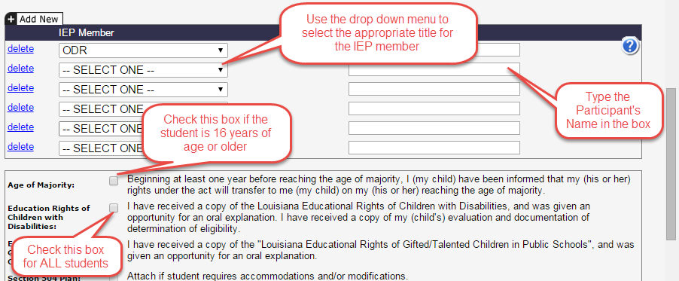
Information to Include on the GSI page when the Case Manager is writing a “Draft” IEP
- General information about the student—Write a general description of the student.
  - Report the following:
- Age, Grade
- Reason for the IEP meeting (i.e., annual review, re-evaluation review, failing grades, excessive absences, eligibility for April Dunn Act, etc…)
- Exceptionality
- Related services, if applicable (for example: Speech, OT, PE, APE, Counseling)
- Primary language and modes of communication
- Type of vision loss
- Communication needs (why do they need to be here)
- If the student were glasses/contacts, mention it in this section too.

- Strengths—Write a description of the student’s strengths (what the student is capable of doing independently).
  - Report academic strengths
  - List what the student’s strengths are according to the most current Evaluation/Re-Evaluation report
    - Sample wording: “According to the most current Evaluation/Re-Evaluation, the student’s strengths include the following: ...”
  - Also list what strengths the current classroom teacher reports
    - Sample wording: “Teachers’ reports indicate the student exhibits the following strengths…”

- Parent concerns—Address the concerns of the parents for regarding the education of their child.
  - Leave this box blank until the IEP conference.
  - The ODR will handwrite all comments that the parent(s) mention during the meeting in this box.
  - After the meeting is complete, the IEP Facilitator will type those comments into SER.

- Evaluation/Reevaluation Results
  - Enter the student’s current evaluation/reevaluation information.
  - Sample wording: “According to the student’s reevaluation on (date), he/she continues to qualify for Special Education services, due to 1508 exceptionality of _____ (type of disability).”
  - Sample wording: “He/she meets the criteria to receive Speech & Language Therapy, Counseling, APE, OT, PT, and/or any other related services.” (if applicable)

- Academic, Developmental, and Functional Needs
  - Report specifically what areas the student needs assistance/improvement.
  - How the student’s disability affects the student’s involvement and progress in the general curriculum. For a review IEP, the IEP team revises the IEP to address any lack of progress toward the annual goal.
  - Must be very specific in what the student is able to do and unable to do.
  - Enter data from classroom based assessments, statewide assessments, formal standardized testing.

- Statewide Assessment Results
  - Make sure the test scores are current and complete. (obtained from JCAMPUS)
  - Sample wording: “According to the statewide assessment results, the student participated in the _____ assessment in the Spring of 20__ and received the following scores: ELA-(number score) Approaching Basic, etc...
  - Include the past three years of assessment scores for April Dunn Act students.
  - Statement why student qualifies for April Dunn Act, if applicable.
  - Statement why student qualifies for LEAP Connect, if applicable.

- Progress or lack of expected progress in the general education curriculum
  - Report the most current report card grades for each subject. (obtained from JCAMPUS)
  - Report the number of objectives the student has either “achieved” or made “sufficient progress” on according to the most current progress report period and it what areas.
  - Some Examples of Possible Wording:
    - “According to the student’s current Progress Report, he/she achieved ___ out of ___ IEP objectives in the areas of : ELA, math, Communication, etc., using ______ (accommodations: hand-over-hand/modeled/prompted support/independently, etc…).” or “The student has made sufficient progress on ___ out of ___ IEP objectives in the areas of; ELA, Communication, math, etc...”
    - “The student’s most recent report card grades are: ___.”
    - “According to his/her educational history, he/she started school in pre-K and progressed to ____ grade, having repeated no grades.
    - Report number of absences. (obtained from JCAMPUS)
    - Example of wording:
      - According to JCAMPUS, the student has ___ absences to date. ”

- Behavior
  - Report any discipline referrals that are documented. (obtained from JCAMPUS)
  - If a student has a behavior plan, mention that in this box.
  - Example of wording:
    - “The student successfully participates in the Positive Behavior Support program at LSD. Discipline records from the __-__ school year note ___ discipline referrals. According to JCAMPUS, the student has ___ absences to date. ”
**If there is a concern for behavior, the IEP team needs to complete a Functional Behavior Analysis (FBA) first. Add a comment about following up with an amendment to the IEP if a Behavior Intervention Plan (BIP) is necessary.**

- Limited English Proficient
  - Sample wording:
    - The student’s primary language is English.

- Communication Needs of Child
  - Sample wording:
    - “The student’s primary language is _____ (spoken English, ASL, etc...).”
    - “The student’s primary Receptive Communication Mode(s) is/are _____ (from Communication Plan). His/her primary Expressive Communication Mode(s) is/are _____ (from Communication Plan).
    - “Speech is intelligible/unintelligible at word/sentence level.”
  - If the student is eligible for speech services… include a similar statement as follows: “He/she also meets the criteria to receive Speech & Language Therapy as a related service and attends sessions weekly.”
    - Specifically indicate the speech and language deficits.

- Instruction in and use of Braille
- Filled in by student’s Braille teacher, if applicable

- Assistive Technology Services/Devices
  - Only write down those devices that will be used throughout the day in all classes.
  - Some examples of AT devices:
- Magnification devices, closed circuit television, talking calculator, large print calculator, zoom ext. screen reader software, white cane, calculators, etc.

- Health Needs (obtained from JCAMPUS)
  - Include the information regarding the student’s Health Care Plan and Emergency Care Plans
  - Example of wording:
    - The student has an Individual Healthcare Plan. “According to JCAMPUS, he/she has the following medical conditions: ______. Currently, he/she is taking the following medications: (name of medications).” Any other information on IHP, also include.
  - All students must have current vision and audiological assessments reported:
    - “The student has passed a pure tone screening on (date), he/she has an adequate hearing for educational purposes.”

Transition Course of Study (if applicable)
- If the student is of transition age, then you must select the appropriate Transition Course of Study.

Educational Needs
- Select the appropriate Educational Needs for the student.
- Academic/Cognitive – Needs in the academic areas such as reading, written language, and mathematics, and/or in the cognitive needs such as acquisition, manipulation, organization, storage, retrieval, and expression.
- Behavior – Needs of the student when his or her behavior impedes learning or the learning of other students.
- Communication – Needs of the student in understanding and communicating with others, such as writing and language development, articulation, augmentative/adaptive methods, etc.
- Motor – Needs may include fine and gross motor movement, such as handwriting and walking, etc.
- Self-Help – Needs may include toileting, dressing, safety, health needs such as self-catheterization, insulin maintenance, etc.
- Social – Needs may include peer interaction, strengthening self-concept, etc.

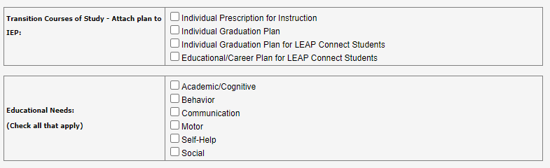

SER #3: Instructional Plan
- The Instructional Plan has one Goal per page.
- If an Educational Need Area is checked on the GSI, then the Instructional Plan page is automatically populated.
- As many Instructional Plan pages can be populated as needed – just click on ADD NEW to create an additional Instructional Plan page.

April Dunn Act applied
Check this box if April Dunn Act will be applied to the goal. You must first select “Academic/Cognitive” on the General Student Information page in order for the April Dunn Act box to be accessible on this page. Check this box if you intend to apply April Dunn Act alternate performance criteria to a course. Click Edit to select the course where April Dunn Act will be applied (a Tip box appears after clicking Edit). Find a course by typing the first letter of the course name or the full course code. A list of results will appear. If no results appear, try a broader search using fewer letters. If the student is in grades T9-12, the course where April Dunn Act is applied is required.

Date Goal Achieved
Fill in the actual date on which the annual goal was achieved by the student.
For April Dunn Act applied courses, the teacher of record must be included in the plan for monitoring and assessing student progress throughout the duration of the course since he/she will be awarding the course credit if earned.

For April Dunn Act promotion criteria, the IEP team will determine if the student has met IEP goals; determine if the student has met minimum skills/competencies necessary for promotion as defined by the teacher; and if necessary, review the promotion recommendation made by the teacher and determine if promotion to the next grade is appropriate.

Present Level of Academic Achievement and Functional Performance
The present level of academic achievement and functional performance is a written description of the student’s strengths, weaknesses, and learning styles. Based upon information from a comprehensive evaluation, these descriptions are both concise and meaningful, identifying a student’s needs. Because the annual goals and short term instructional objectives are based on the information contained in the present level of educational performance, it is the foundation of the IEP. The information provided in this section directs how the goal is written.

The following are key components of the present level of educational performance:
• Baseline data needed to track the student’s progress and for the progress report.
• Description of the student’s strengths, including the deficit areas. By including a description of what the student can do, one will know where to begin writing the annual goals and short term instructional objectives and where to begin the instructional program.
• Description of specific weaknesses demonstrated by the student. The weaknesses should be stated in simple language that is free of educational jargon and which describes specific student behaviors.
• Answers the question “What is the student doing now? How does the student perform today?”
• Gathered from formal and/or informal assessments and may include a description of behaviors in and out of school.
• Reflects the results of the evaluation(s). These statements are based upon data acquired from administering a variety of diagnostic procedures such as, formal/informal test, observations, anecdotal records, and interviews. An explanation of any test score referred to in the present level of educational performance should be provided with the measurement tool identified.
• Incorporates information regarding the student's learning style including a description of the techniques and/or materials that have proven particularly to be effective or ineffective.
• Avoids statements of where, when, or how special education services will be provided. This information does not belong in this section of the IEP and cannot be determined until the goals and objectives are developed.

Measurable Academic/Functional Goal
Write an annual measurable academic and functional goal based on statements about the student’s present levels of academic achievement and functional performance. Careful consideration must be given to address the student’s specific needs. A goal statement must describe the specific behavior expected of the student when the educational program for the year is completed, and the goal must be stated in measurable terms so that each team member, including the parent, understands what is expected.

One method is to use the acronym SMART – Specific, Measurable, Achievable, Relevant and Time bound.

• The purpose of the annual goal is to describe what a child can reasonably be expected to accomplish within 12 months with specially designed instruction and related services. Annual goals enable the child to be involved in and progress in the general curriculum. They are also intended to meet other educational needs that result from the child's disability or exceptionality.
• Prioritize the student’s needs by asking “What prerequisite skills/knowledge does the student need to close the gap between his/her present level of performance and the grade-level expectations?
• Goals must be standards-based. Repetition of a content standard, benchmark or grade level expectation as a goal is not appropriate nor is it standards-based. For students being assessed with the Louisiana Connectors this information must be reflected in the student’s goals and objectives.
• Academic content areas should be separated (ELA, reading and/or math content areas should not be combined into one goal). Within content areas – it may be necessary to write more than one goal – for example in English language arts (reading) a student may have a need for phonological awareness, vocabulary building, reading comprehension, decoding, etc. and for Mathematics – basic math facts – addition, subtraction, multiplication, division, how to use a calculator, working word problems, following multi-step problems.
• What other areas are difficult for the child? What additional skills does the student need to be successful – socially, behaviorally, organizationally, etc.? Consider behavior, motor, social-emotional, communication, self-help. It must address appropriate activities for the preschool aged child. Emphasis should be placed, whenever possible, on the integration of all related service goals throughout the student’s program.
• Goals set the direction for working with the child by providing a way of determining whether anticipated outcomes are being met, and whether placements and services are appropriate for the child's special needs.
• The data collected through progress monitoring (e.g., grades, progress reports, behavior checklists, task analyses, teacher observation logs, etc.) shall be reviewed to determine the progress the student makes toward acquisition of the measurable annual goals and/or objectives/benchmarks. This same data will be used to support whether the student meets any of the criteria for ESY eligibility.

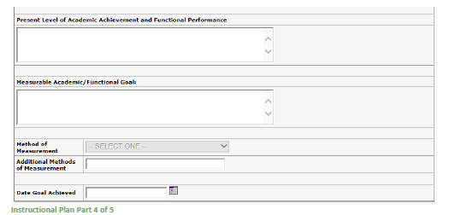

Short-Term Objectives/Benchmarks

The Student Will: For those students who are participating in alternate assessments or who are pursuing alternate performance criteria because they are April Dunn Act eligible, write short-term objectives that describe intermediate steps or benchmarks that describe major milestones that lead to the annual goal. Objectives or benchmarks must be written in observable student behaviors and must be specific and clear. Special conditions such as the need for specialized instructional materials or adaptive equipment should be included. Evaluative criteria must be included in the performance standard to determine the achievement of the objective or benchmark. These criteria should indicate the minimum acceptable standard for the student’s performance and the ability to meet the criterion consistently and reliably over a period of trials (e.g., without an error in nine out of ten trials) or average a period of time (e.g., ten times a day for a week without error).

Short-term objectives must contain the following:
• a statement identifying the target behavior
• the conditions under which the behavior is to occur
• the criteria of acceptable performance, including the method of measurement
• the terminal point of review, when will it be no longer necessary to continue teaching or assessing the skill
• the measurement instrument by which student’s progress will be measured.

Components of a Short-term Objective
Behavior: be specific and define in very clear terms what behavior the student is to perform o Observable – must describe an overt behavior, one that can be seen by observers
o Measurable – a behavior that can be monitored and evaluated as to allow measurement of a student’s progress toward meeting the objective
o Verifiable – has the behavior occurred
• Condition: the conditions tell about the environment, specialized instructional materials and/or equipment needed by student. (By providing a statement of the condition, you help to ensure that the teaching condition is consistently reproduced.)
• Criteria: standards that will establish if a behavior has been learned or acquired. They describe how well the student must perform the behavior and provide the basis for evaluating mastery of the objectives.
• Parameters of Proficiency
o Accuracy – doing the behavior correctly. Accuracy is usually determined by comparing the number of correct behaviors or the number of errors to the total number of behaviors. Accuracy data is most often expressed as a percentage. For example: John got 90% of the math problems correct.
o Mastery – doing the behavior accurately and quickly. Mastery is usually determined by comparing the accuracy of the behavior to the speed at which the behavior is completed. Mastery is expressed as a rate. For example: Joan read a passage at 75 words per minute with 0 errors.
o Automatic – doing the behavior accurately and quickly in the presence of relevant distracters. Automatic functioning is usually determined by having the student do a task in context. Automatic data is usually reported as a rate and sometimes only as accuracy. For example: Tommy’s spelling in his paper about the water cycle was 95% accurate.
• Terminal Point of View: each objective should include a statement that provides a terminal point of review. A statement specifying when it will no longer be necessary to continue teaching and assessing the skill.
For example:
o 90% correct, 3 consecutive sessions
o 8 out of 10 trials, 4 out of 5 sessions
o 3 times per hour, 5 consecutive school days
• Identifying Measurement Instrument: the instrument that will be used to document the student’s performance should be specified. For example o as measured by teacher checklist
o as measured by pre and post tests
o as measured by progress monitoring

Date Achieved
For those students who are participating in alternate assessments or who are pursuing alternate performance criteria because they are April Dunn Act eligible, write the actual date on which the objective or benchmark was achieved by the student. This date should be indicated immediately after mastery of the short-term objectives or benchmarks. Progress or lack of progress toward achievement of objectives or benchmarks should be described in the progress reports.

Personnel Responsible for Implementing Goal
Check the position(s) of the individual(s) who will implement the instructional program that addresses the annual goal. There may be one or more persons responsible for a particular goal and/or objective. These persons may include the special education teacher(s), regular education teacher, parent, student, speech/language pathologist, adapted physical education teacher, or other related service providers.

For April Dunn Act applied courses, the teacher of record must be included in the plan for monitoring and assessing student progress throughout the duration of the course since he/she will be awarding the course credit if earned.

Emphasis should be placed on the integration of goals, including related service goals, throughout the student’s program.
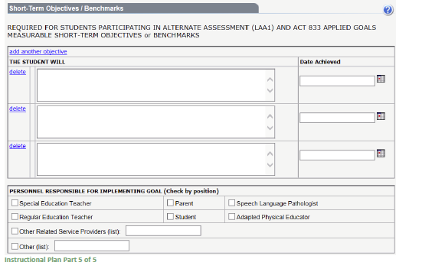

SER #4: Accommodations

- Accommodations change how students learn and the ways they demonstrate what they have learned. The students are working on the same instructional objectives and content as the other students.
  - An accommodation is any technique that alters the academic setting or environment to help a student access the curriculum and validly demonstrate learning.
  - An accommodation generally does not change the information, amount of information learned, or performance criteria. It merely provides the extra time, the special setting, and/or the added assistance that enables learning and accurately assesses the student’s real knowledge rather than assessment of the disability.

- Accommodations should be selected for classroom instruction and assessments within the first columns of the accommodations page. Accommodations for state assessments should be selected from those available for each format and grade level. Because of the current transitions between online and paper assessments, IEP teams should indicate for both paper (grades 3 and 4 for LSVI) and online assessments what would be most appropriate for the student.

- The accommodations documented for a student should be accommodations that the student receives routinely in class and are listed in the IEP as instructional accommodations. Providing a student with a test accommodation that is not used routinely in class may prove to be more confusing than helpful for a student and is not allowed.

- Plan how and when the student will learn to use each new accommodation. Be certain there is ample time to learn to use instructional and assessment accommodations before an assessment takes place. Finally, plan for the ongoing evaluation and improvement of the student’s use of accommodations.

- Below are a list of headings on the Accommodations page from SER:
  - Presentation Accommodations-alters the format of delivery
  - Response Accommodations-allows for alternate methods of providing responses
  - Timing & Scheduling-changes the allowable length of time, the time of day, or how the time is organized
  - Setting Considerations-changes to the setting including grouping
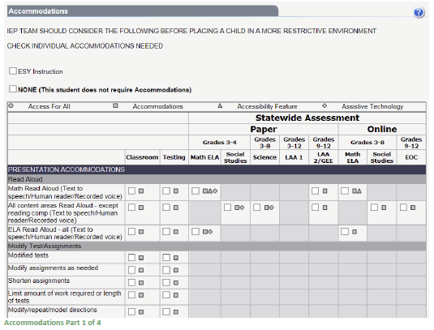

SER #5: Program and Services

Louisiana Educational Assessment Program
- Below are the options for state testing tracks:
  - Regular Assessments
  - Alternate Assessment
    - LAA1—new LAA1 form to “add” to the IEP
  - None—option is selected only under one of the following two conditions
    - Prekindergarten through second grade students
    - Graduating seniors who have passes the required components of the exit examination
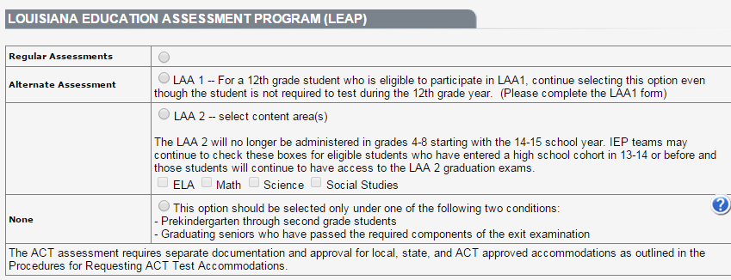

April Dunn Act Eligibility

April Dunn Act of the 2014 Legislative Session provides certain students with disabilities the ability to demonstrate proficiency through alternate means rather than on state assessments or relative to standard local pupil progression plans required for promotion and graduation.

April Dunn Act eligibility decisions fall into two categories: 1) Promotion and 2) Alternate Graduation Pathway, only one of which will apply at any given IEP meeting (depending upon the grade in which the student is enrolled).

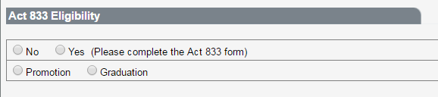

A Yes or No answer must be checked for all students with disabilities. If Yes is chosen, check whether the decision is being made for Promotion or for Graduation. When Yes is chosen, the April Dunn Act Eligibility Criteria Determination Form will be added to the IEP Forms list selection. The April Dunn Act Eligibility Criteria Determination Form can also be added or deleted to the IEP Forms list selection. See Additional Forms for more information.

Once a student is determined to be eligible for an alternate pathway to a high school diploma (Graduation), and this has been documented on the form, this decision does not need to be made again. Therefore the eligibility determination (Yes), the category (Graduation), and the eligibility determination date will automatically populate on all subsequent IEPs. The Eligibility Date Determined field is disabled on the April Dunn Act form.
If No is chosen, move to the next section of the IEP.

Details regarding these decisions are provided on the charts below.

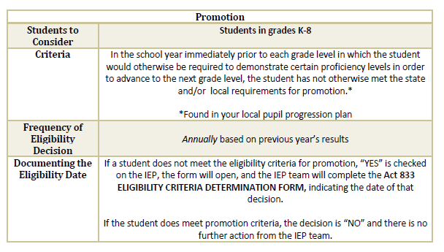

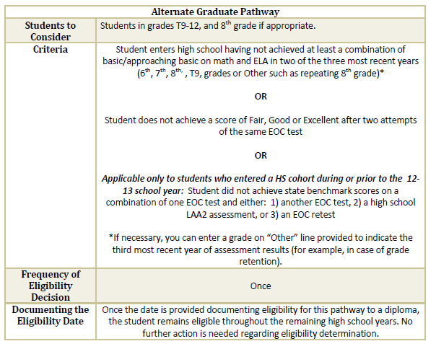

Note: A student assessed on the alternate graduation pathway does not have to be eligible under April Dunn Act to pursue the Career Diploma Pathway for students assessed with LEAP Connect. By virtue of being assessed with LEAP Connect, a student is eligible to pursue the Career Diploma Pathway for students assessed with LEAP Connect. For example, if a student passes the alternate assessment and then an answer of No is chosen for eligibility for an alternative pathway to graduation under April Dunn Act, the student is still eligible for the Career Pathway for students assessed with LEAP Connect.

Regular Classes box
- If not in regular classes, explain (LSVI’s students are not in regular classes)
  - Sample wording: “LSVI has no regular classes on this special school campus and _____ does not mainstream. However, it is important to note that he/she is in need of placement in a separate school which is not a continuum of the least restrictive environment for students who are visually impaired/Blind.”
  - The student requires individual/small group support and instruction at a separate school with staff trained in the education of the visually impaired/blind.

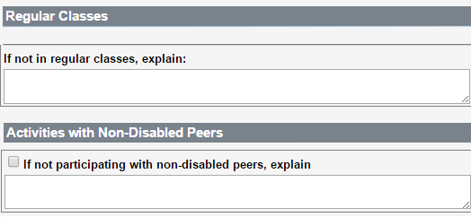

Student’s Total Instructional Day (minutes)
LSDVI
- 364 minutes Total minutes should be 1820
- Student attends school 5 days a week.
- Add the following services:
  - Special Education Instruction
  - Any other related services needed, Speech Language Therapy, Counseling, OT, PT, APE, etc…

Services section
- Services: Drop-Down menu. Select the appropriate service.
- Time Frame Name: Can either be left BLANK or “IEP year” can be typed in
- Trigger Date: If there is a second time frame needed, a trigger date must be entered as to when to begin the second time frame.
- Date To Begin: Indicate the actual date the student will begin to receive special education service (s); usually the date of the IEP meeting
- Duration: Indicate how long (e.g., one IEP year) these services will be provided
- How will the service be provided: Individual/Group/Both/NA
- Where student will receive special education services? Indicate the actual minutes per day/sessions per week of direct and/or related special educational services the student will receive in each actual location - regular class, community and/or special class.

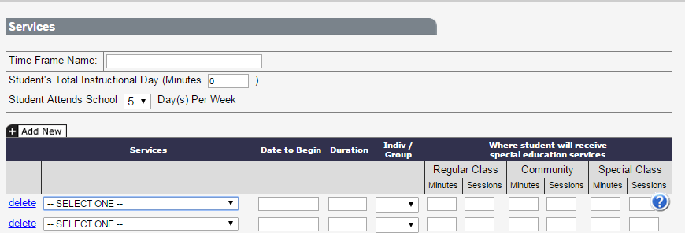

Comments
- List participants excused
- Communication plan completed/agreed upon
- Alternate Assessments discussed/agreed upon
- Note: Any Parental comments should be placed in the “GSI: Parental Concerns” box not in this box.

Supports Needed for School Personnel
- Sample wording: “Accommodations appropriate to the student's support needs will be discussed with the appropriate instructional and support staff members. Health care plan(s) and/or emergency care plan(s) will also be discussed with the appropriate staff and personnel.”
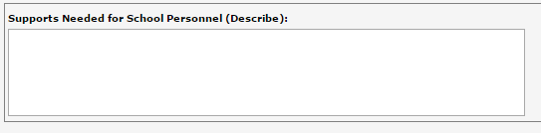

Special Transportation
- Yes/No Choice
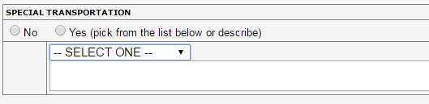

Extended School Year Services (ESYS)
- Check box as appropriate
    - Regression/Recoupment (R/R)
      - for all students with significant cognitive disabilities
      - And Preschool-aged students
    - Critical Point of Instruction 1
      - Typically this option is not marked
    - Critical Point of Instruction 2
      - for students at risk of losing significant progress made towards acquisition, fluency, maintenance, and/or generalization of skills relevant in the pursuit of critical life areas (ex. self-help, community access, or social/behavioral skill areas)
    - Special Circumstances
    - Employment
    - Transition from Early Steps to Pre-school
    - Transition to Post-School Outcomes
    - Excessive Absences

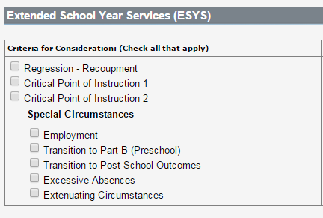

SER #6: Service and Placement
Placement/Service Determination Checklist
- Check box for Separate School
- A comment must be made as to why the student is being placed in a “Separate School”
- Consider the following wording:
  - LSVI- “The IEP committee has determined that the student needs individual instruction and low teacher to pupil ratio to successfully address the General Curriculum. He needs Braille instruction and instructors that are trained to meet his needs in the education of the visually impaired/blind. LSVI can provide this on a daily basis.”
  - LSD- “The student benefits from a language intense environment supplemented by communication and other techniques developed for the education of the Deaf. Due to his/her's identified educational support needs and his/her need for instruction presented in ASL, he/she is in need of placement in a separate school which is not a continuum of the least restrictive environment for students who are deaf.”

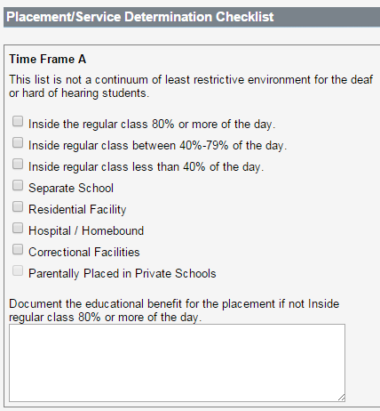

Progress Reports
- Type in “9” in the box.
- IEP Progress Reports will be completed every 9 weeks
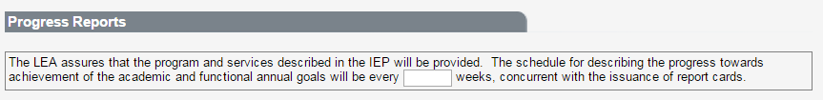

Alternate Assessment Implications (if applicable)
- If the student is participating in an alternate assessment, the ODR must read the statement to the parent and then select the appropriate box.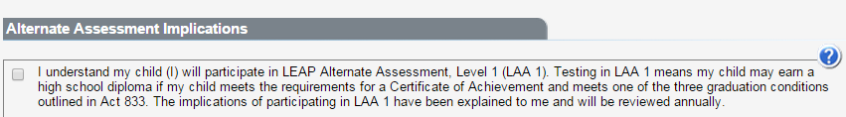
Parent/Student Consent for Services
If this is an INITIAL IEP, written parental consent (parent signature) is required prior to special education and related services are provided. The IEP cannot be made OFFICIAL without the parent’s signature. See Placement/Least Restrictive Environment Part 4a of 5. If the parent refuses services, the draft IEP must be deleted from SER. A copy of the draft IEP with the parent indicating refusal may be kept on file for documentation.

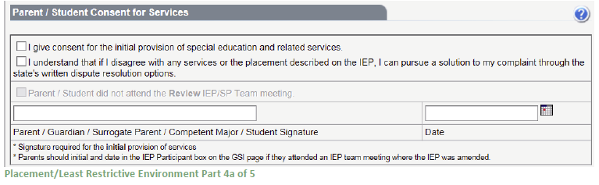

For REVIEW IEPs, the parent/student is an IEP team participant but does not sign consenting to continue services. See Placement/Least Restrictive Environment Part 4b of 5. The district is responsible for the provision of FAPE. If the parent/student disagrees with the special education and related services or the placement described on the IEP, the parent has the right to pursue a solution to their complaint through the state’s written dispute resolution options.

Parent did not attend the Review IEP Team meeting.
Check the box – Parent/student did not attend the review IEP Team meeting – if the parent did not respond to the notice letter or other attempts to schedule the IEP Team meeting or did not attend the Review IEP Team meeting.

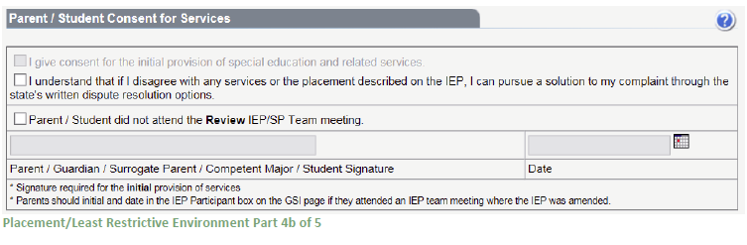

Revocation of Consent
If the student is currently receiving services and the parent refuses all special education and related services, the parent must be given the Revocation of Consent notice letter. The IEP is not made Official. It is advised that the special education teacher then contact their special education director/supervisor or their designated representative to inform them of the parent’s revocation of consent for services. This process is not used with Initial IEPs.

Supporting Documentation
In the course of a student’s IEP, additional forms may need to be completed and attached to the IEP. Click on the link to access the appropriate form. All forms are in PDF format. If the forms are highlighted, they can be downloaded, completed, and then uploaded using the attachment feature. Other forms can be completed and then uploaded using the same attachment feature. See View Attachments for more information.

ODR Approval
The official designated representative of the LEA must provide a dated signature indicating the LEA will provide the services as described on the IEP.

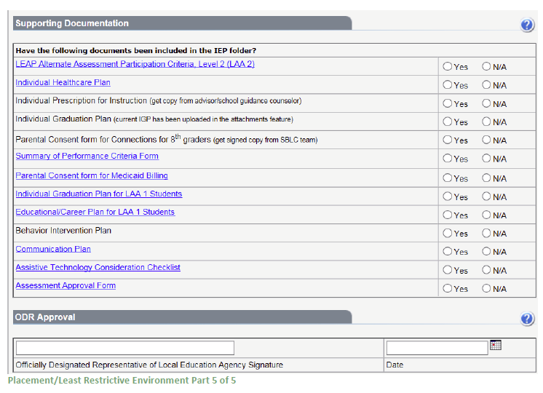
SER #7: Site Determination
- This page must be “added” to the IEP
  - Sample wording:
- LSVI- “The student support needs include instruction by staff members using methods specific to the visually impaired/blind. LSVI is a separate school and his classroom contains accessible instructional materials for the visually impaired/blind and is not integrated with regular classes.”
- LSD-“LSD is not the school that the student would attend if he/she was not identified as Hearing Impaired-Deaf/Hard-of-Hearing. He/She attends LSD due to his/her exceptionality, direct communication and instruction by certified teachers who can sign, and IEP committee decision. LSD has no regular classes on this special school campus.”

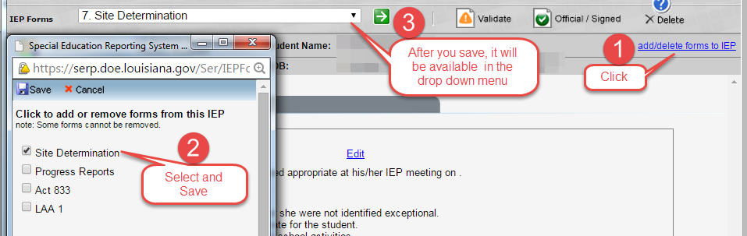

Adding the Site Determination Code
- Click “Edit”
- Enter Code “304001”- LSD and “304002”- LSVI
- Select either “Louisiana School for the Deaf or “Louisiana School for the Visually Impaired”
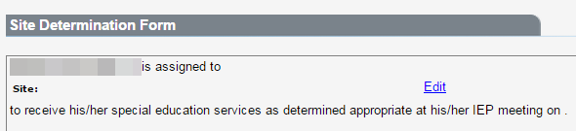
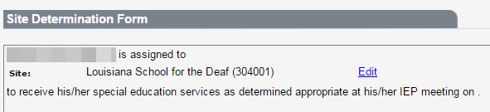
Printing an IEP
- ALWAYS select the option to “Print Partial State ID Number”, except when printing Progress Reports
- Mark the pages you want to print.
- Click “Print”
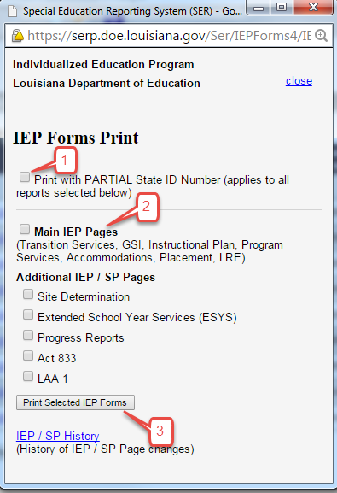

Section V: Closing Out IEPs and IEP Progress Reports

Closing Out IEPs and IEP Progress Reports

- Before writing new goals and objectives, the case manager must look at the previous IEP to determine which goals and objectives have been marked as achieved by the case manager and/or teacher.

- If the goals and objectives have been achieved, the case manager must record those specific dates.

    - Type in SER on each Instructional Plan page AND write on old IEP (hard copy).
    - If goals and objectives have been NOT achieved, you do not write in dates.

- Next, the case manager will go into the Progress Reports in SER
  - Enter a new reporting period with the “closing date” of the IEP
  - The “closing date” is the date that the goal was achieved or the day prior to the new IEP date.

- Each Instructional Plan page in the Progress Reports should have no less than 4 reporting periods (with some exceptions).
  - The “progress towards goal” will be either “Achieved” or “Sufficient Progress”.
  - In the “Current Data” box if the goal has been achieved, type in current data with achievement level (i.e., specific data (percentages) to document how the student is performing on that specific goal and objectives).
  - In the “Current Data” box if the goals have not been achieved but “Sufficient Progress” was made, type in the current data (i.e., specific data (percentages) to document how the student is performing on that specific goal and objectives). Also comment as to whether the goal will be continued to the next IEP OR if the goal will be revised on the next IEP.

- If a student withdraws from LSDVI, the goals and objectives must also be “closed out” by the case manager.
  - Go into SER-Progress Reports.
  - Add a new “Reporting Period” with the date of withdrawal.
  - Enter data (i.e., specific data (percentages) to document how the student is performing on that specific goal and objectives).
Section VI: IEP Progress Report Procedure

IEP Progress Report Procedure

- Each nine weeks period, IEP progress reports are required on every student.

- How to Add a Progress Report:
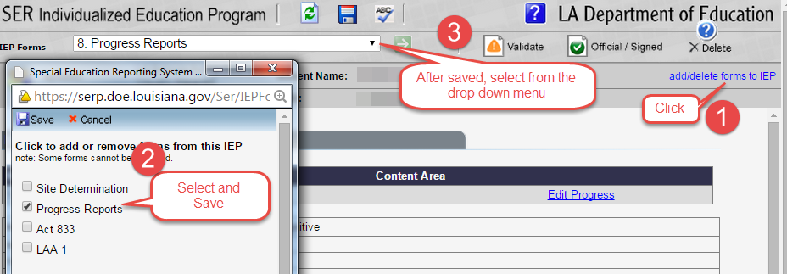

- Case managers will be responsible for collaborating with all the students’ teachers to determine progress towards IEP goals and objectives.
    - Teachers need to report what percentage the student is performing on the IEP goals and objectives.
    - Progress will be entered by the case manager for those students on their case manager list.
      - Entries can be written as follows: “According to the student’s ELA teacher, he/she can define vocabulary with 50% accuracy with teacher assistance. According to the student’s Science teacher, he/she can define vocabulary with 55% accuracy with teacher assistance.”

- At the end of the 9 weeks period, the case manager will use the documentation obtained during the collaboration meetings to complete ALL the progress reports for the students on their list with the following exceptions:
  - The following pages will be completed by the service provider:
    - Speech Therapist’s Communication Instructional Plan page (completed by the Speech Therapist)
    - PT’s/APE’s Gross Motor Instructional Plan page (completed by APE)
    - Behavior Instructional Plan pages (completed by Counselors and/or School Psychologist)
    - Counseling Instructional Plan pages (completed by Counselors and/or School Psychologist)

- All teachers are responsible for all goals and objectives (across curriculum).

- A Progress Report is generated for each Goal with or without Short-Term Objectives on Instructional Plan in the IEP. For each Reporting Period, additional data relative to the goals and short-term objectives can be added to the subsequent progress report by clicking “ADD NEW”.

- Progress Reports (teacher’s name is typed at bottom in signature box) will be mailed home with the Report Card for each 9 weeks period. Copies of Progress Reports must be filed in each student’s IEP folder.

- Baseline Data box for IEP Progress Reports:
  - Baseline data is basic information (where the student is performing as identified in the academic achievement and functional performance section on the instructional plan) gathered BEFORE instruction begins. It is used later to provide a comparison to assessing instructional impact. If the goals and objectives are vaguely defined or undefined, it will be difficult to know what kind of baseline data to gather.

- Reporting Period Date
  - This date is ALWAYS the last day of the 9 weeks period
  - You mark this date as the “reporting period date” as well as “date sent home”
  - I will continue to send emails near the end of the 9 weeks to remind you of the date to be used.

- Progress Towards Goals
  - NA-Not Addressed
  - IP-Insufficient Progress -- Skill/behavior is not on target toward achieving goal
  - SP-Sufficient Progress -- Skill/behavior is on target toward achieving goal
  - A-Achieved -- Skill/behavior is demonstrated consistently over time
    - If achieved before the end of the IEP year, then the IEP must be amended/reconvened to address additional goals/objectives
  - G-Generalized -- Skill/behavior is generalized and is able to be transferred
    - If generalized before the end of the IEP year, then the IEP must be amended/reconvened to address additional goals/objectives

- Insufficient Progress (IP)
  - IP Reason (if needed)
- Frequent Absences/Tardiness
- Medical/Health
- **If a student is absent due to medical reasons, progress should be marked as “Not Addressed” due to medical reasons. Do not mark “Insufficient Progress”.**
- Missing Class Assignments
- 4Missing Homework Assignments
- 5Lack of Preparation -- Materials Skill Review
- Behavior Interfering with Progress
- Lack of Motivation/Participation
- Other (Identify)
- IP is never to be used with the statement: “New IEP; therefore, no progress has been made.”
    - You are to report how the student is doing on the goal even if it is new.
  - If IP is selected, then there must be documentation of all accommodations, modifications, and interventions the student receives within the classroom.
    - A conversation with a parent is required and documented.
  - If the student obtained TWO consecutive “Insufficient Progress” on an individual Instructional Plan, the IEP MUST be amended/reconvened immediately to modify goals/objectives.
  - When you mark “Insufficient Progress”, you are stating that the child has made NO Progress towards attaining the objectives/goal.

- Conversation with Parent Needed?
  - If the teacher feels a conversation with the parent is needed because the student is not making sufficient progress, then it is the teacher's responsibility to follow up on contacting the parent. (with a witness) This conversation can take place by telephone, person-to-person meeting, email, etc.
  - If Insufficient Progress is marked, contact with parent is mandatory!
  - Documentation of this meeting must be submitted to IEP Facilitator using a PM2 form
- Current Data
  - Shows how much progress the student has made since the baseline data was gathered and is reflected in the choice the teacher made above in Progress Towards Goals.
  - ALL progress should be reported in percentages.
  - Subjective information/comments are not measurable.
  - ALL progress should align with a specific objective for each goal.

- Comments
  - Comments made regarding the student’s IEP progress reports are documented in this box.
  - Comments should always be written in a positive way.

- Teacher Signature(s) and date when the Progress Report was sent.
  - More than one teacher's name can be added on this line.
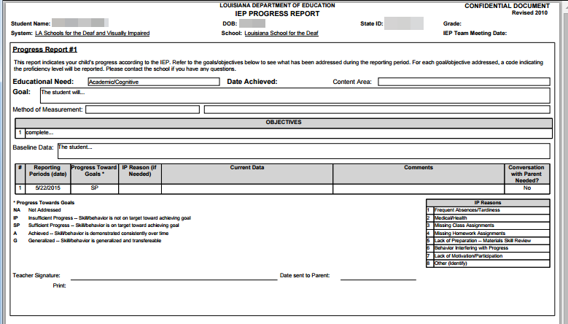

Section VII: JCAMPUS

- Information that can be obtained using JCAMPUS

- When drafting an IEP, JCAMPUS is very beneficial to use.
- You can obtain the following information:
  - Student-Health Information
    - Individualized Health Care Plan (IHP)
    - Emergency Care Plan (ECP)
    - Hearing Results
    - Vision Results
  - Attendance
  - Discipline
  - Grades
  - Student Test Analysis

- Steps to obtain the above mentioned using JCAMPUS

- Log-in to JCAMPUS.
- Select a student.
- Click on “iGear”.
  - Drop-down menu will give you the following choices
    - Student
      - Health Information
    - Attendance
    - Discipline
    - Grades
    - Student Test Analysis
- To obtain student’s Health Information
  - Select “Student”
    - Select “Health Information”
      - Tabs will open
        - Click on “IHP” tab
          - Two more tabs to choose from:
            - “Cover Form”: using the drop down menu, select, and print the most current cover form
            - “Care Plan”: using the drop down menu, select (any and all), and print the most current care plan(s); select the care plan and print one at a time.

        - Click on “Emergency Plan” tab
          - Using the drop down menu, select (any and all), and print the most current emergency care plan(s); select the emergency care plan and print one at a time.
        - Click on “Hearing” tab
          - Print
        - Click on “Vision” tab
          - Print
- Attendance
  - Select “Attendance”
    - Select “Attendance by Day”
      - Print
- Discipline
  - Select “Discipline”
    - Print
- Grades
  - Select “Grades”
    - Print
- Student Test Analysis
  - Select “Student Test Analysis”
    - Print—it will automatically print the entire test history for the student

Section VIII: IEP Facilitator’s Contact Information

I look forward to working with all of you throughout the school year. I will send out emails frequently regarding IEPs, procedures, meetings, important dates, etc… Please read all emails carefully as they will contain information that will be useful to all teachers.

Should you have any questions regarding anything related to IEPs, please do not hesitate to contact IEP Support Services Facilitators.

Contact information:

Debbie Bennett
Exceptional Student Support Services Facilitator
Office Phone: 225-757-3481
dbennett@lsdvi.org
debbie.bennett@email.lsdvi.org

Hillary Robinson
Exceptional Student Support Services Facilitator
Office Phone: 225-757-3459
hrobinson@lsdvi.org
hillary.robinson@email.lsdvi.org

